Week 9 Direct Independent Study Progress

* **Topic Covering**: Al-Powered Phishing Detection Using NLP & Explainable Al.

# **Explainable AI Integration Continuation**

* The GUI has been completed, and now the learning models (Random Forest & Grid Search) can be used to train on a custom phishing emails dataset, which can then help determine if an email received is likely phishing, with details on why it was determined as such (using explainable AI).

**Breakdown**

* Custom Phishing Email Datasets:
  + I combined various phishing email datasets into one to train the model. This was done as, when testing, I found the model to be lacking on specific email types.
  + Emails used came from:
    - CEAS_08.csv – 75,000+ rows
    - Nigerian_Fraud.csv – 5,000+ rows
    - Nazario.csv – 1,500+ rows
    - Ling.csv – 2,500+ rows
    - SpamAssasin – 5,000+ rows
    - TOTAL EMAILS SIZE – 85,000+ rows (Note: rows contain invalid format/values)
    - **True Total emails: 39648 emails**

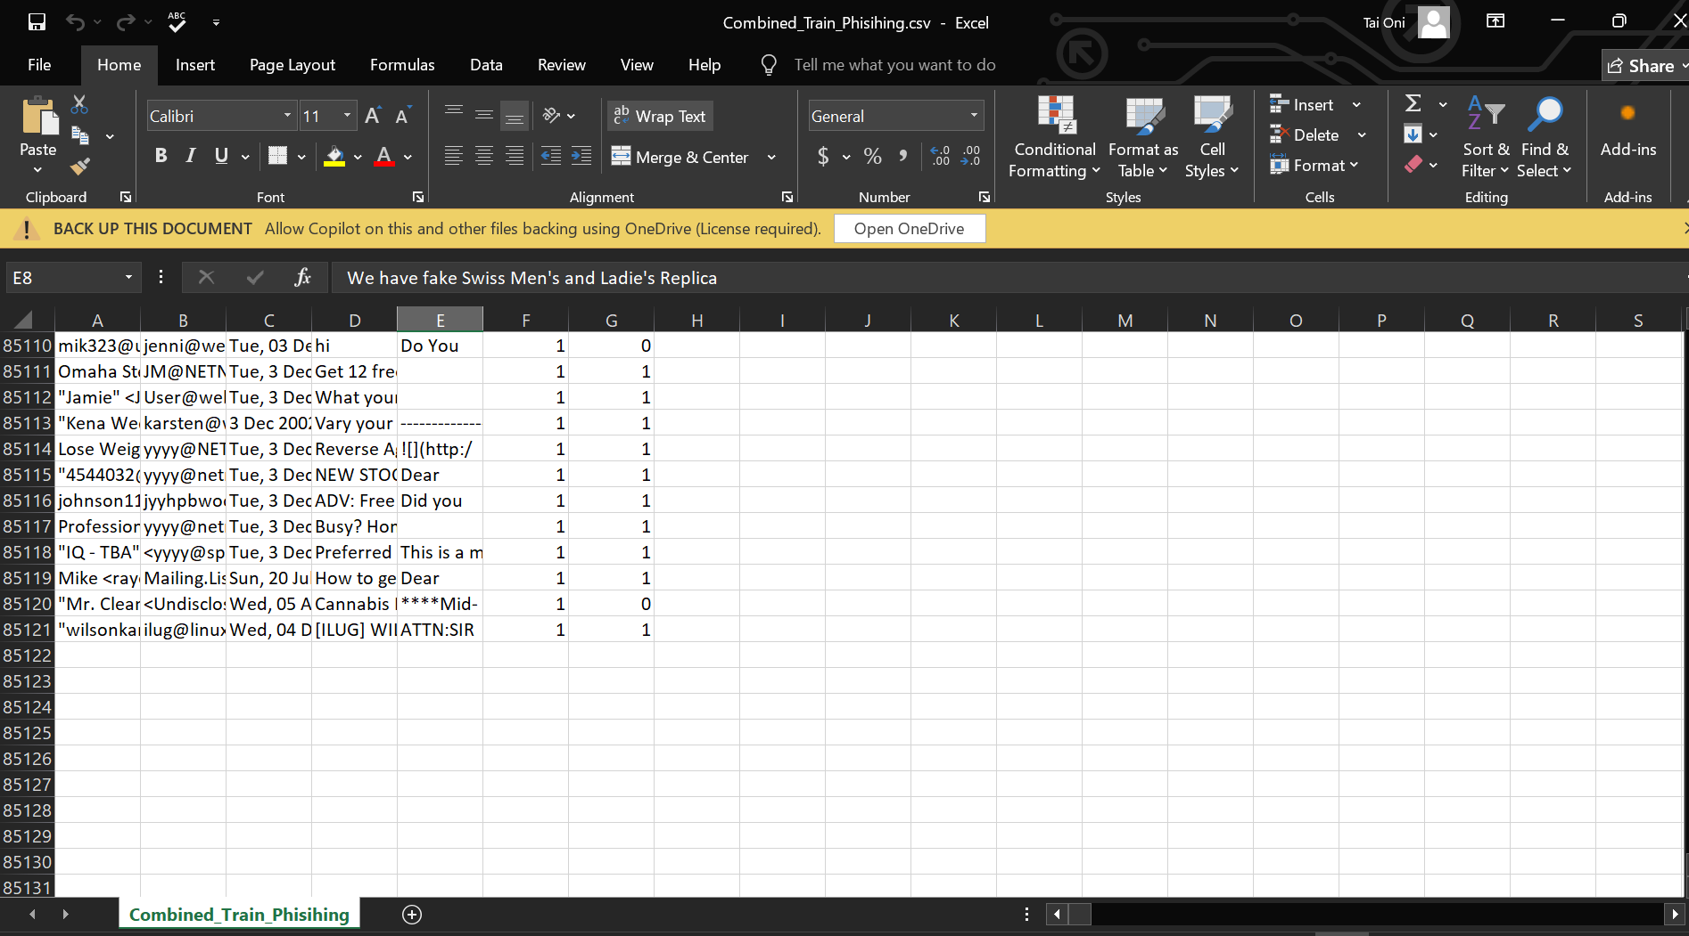

* Running The Program:

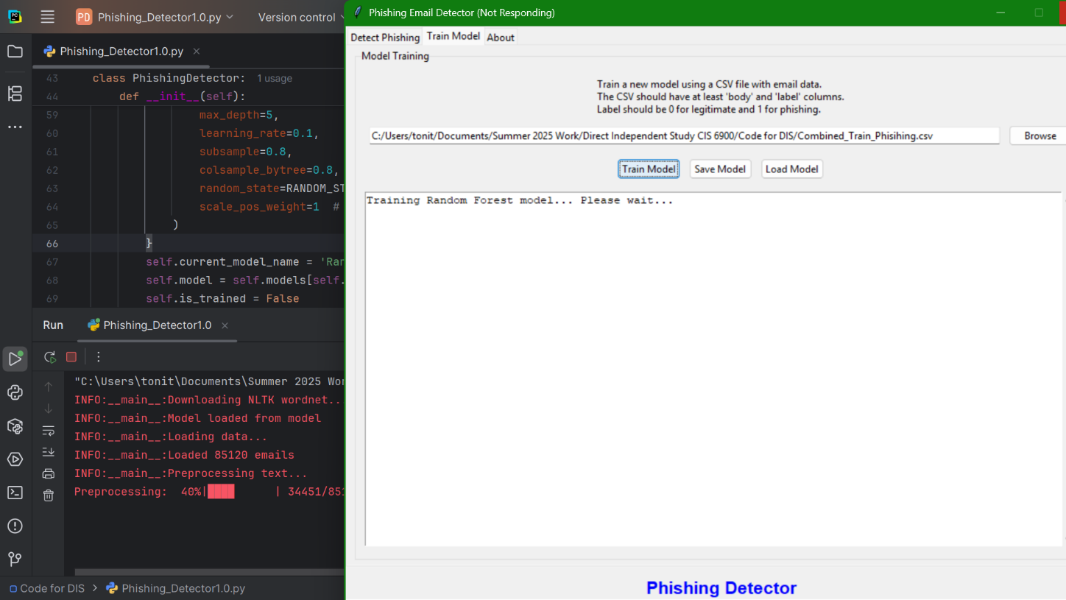

* + From the 85000 rows, 44396 rows were dropped due to invalid labels (caused by the corrupted email format of the file provided).

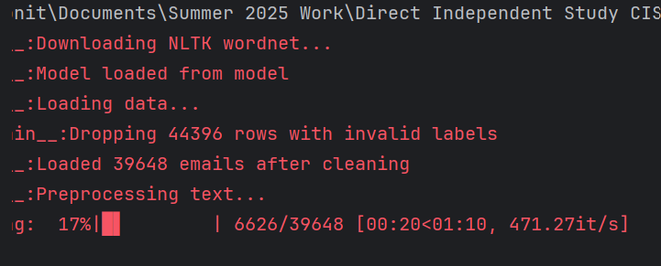

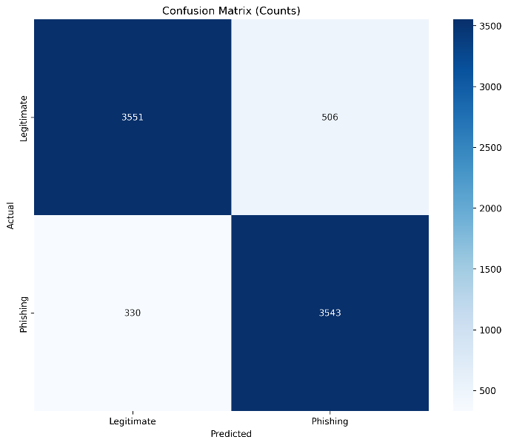 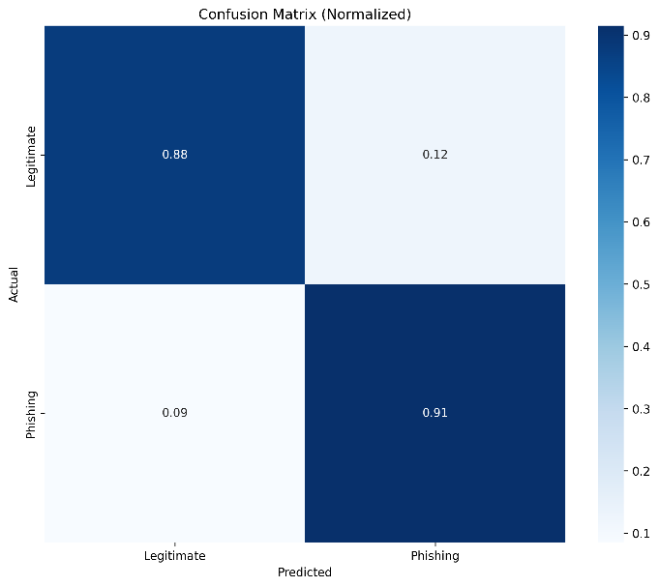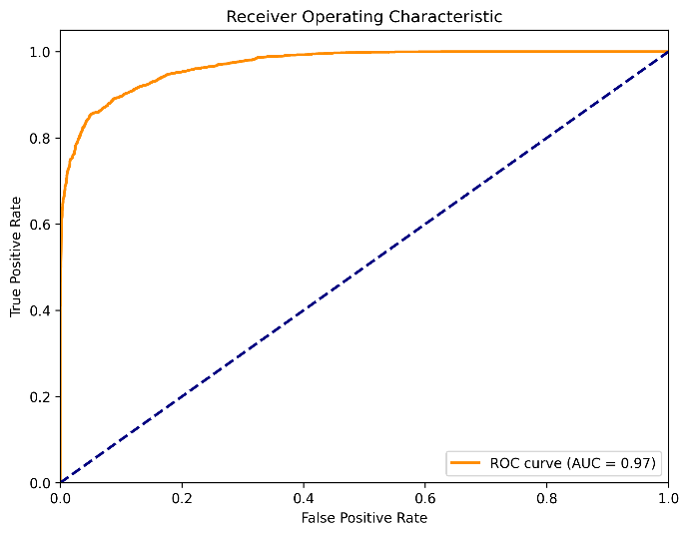

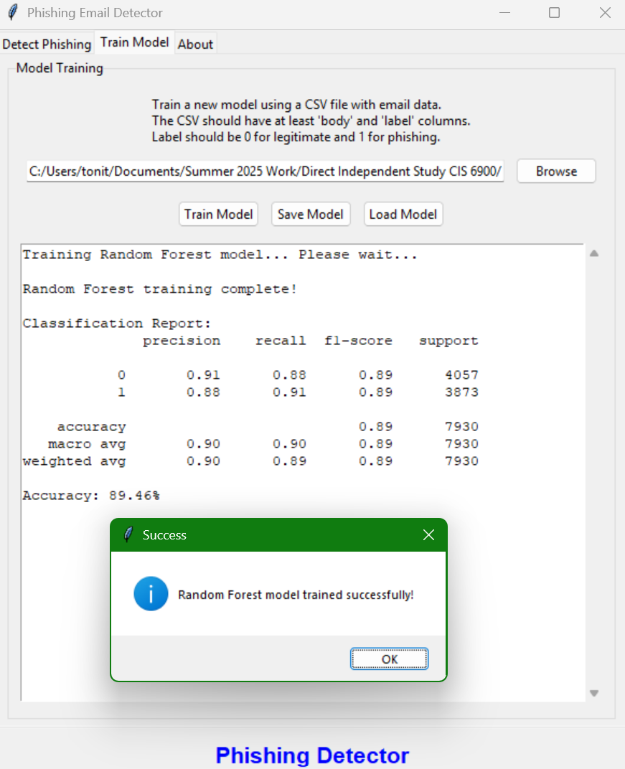

* **Test On Actual Phishing Email Received:**

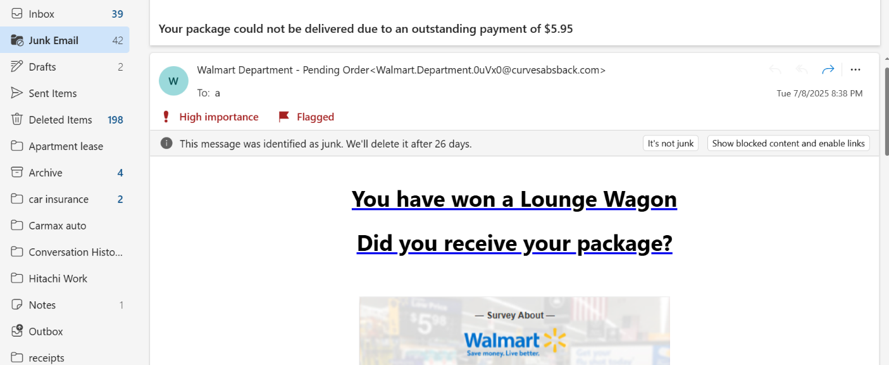

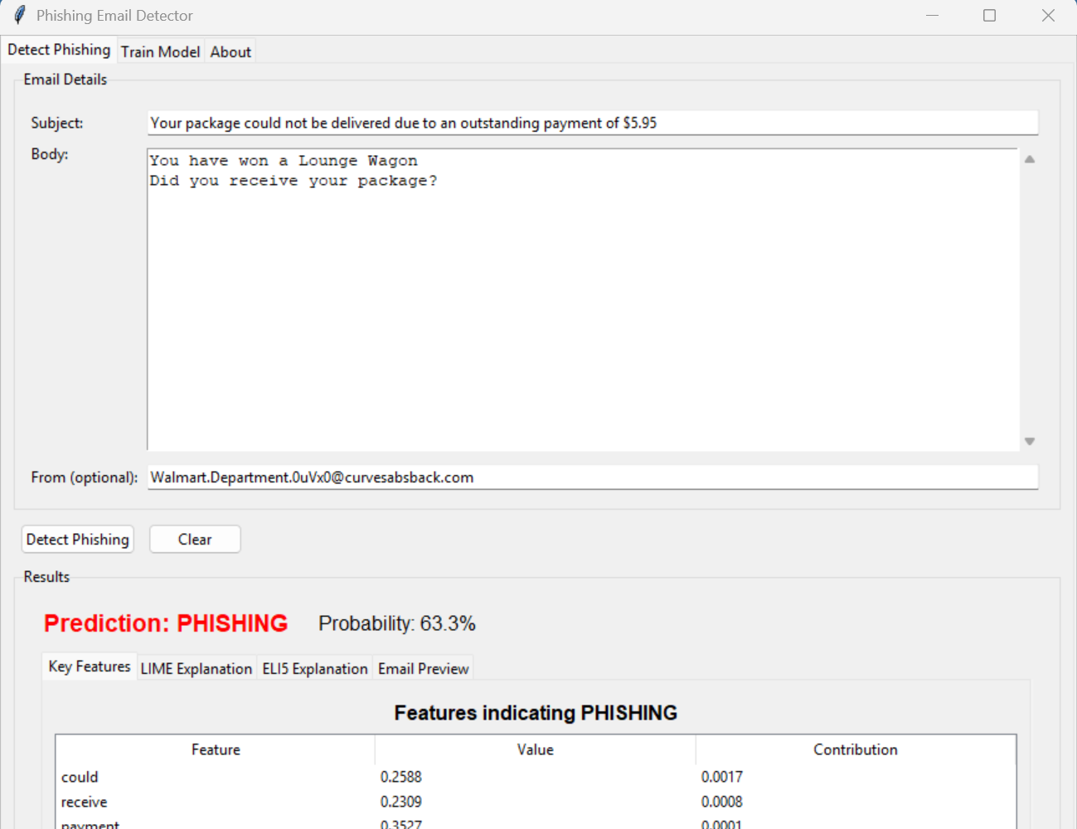

* **Test on Legitimate Email Received:**

